UNITED STATES
SECURITIES AND EXCHANGE COMMISSION
WASHINGTON, D.C. 20549

SCHEDULE 14A

Proxy Statement Pursuant to Section 14(a) of the
Securities Exchange Act of 1934 (Amendment No. )
Filed by the Registrant ☒
Filed by a Party other than the Registrant o
Check the appropriate box:
o |  |  |  |  |  | Preliminary Proxy Statement
o |  |  |  |  |  | Confidential, For Use of the Commission Only (as permitted by Rule 14a-6(e)(2))
o |  |  |  |  |  | Definitive Proxy Statement
☒ |  |  |  |  |  | Definitive Additional Materials
o |  |  |  |  |  | Soliciting Material Pursuant to Rule 14a-11(c) or Rule 14a-12
CAPITAL SOUTHWEST CORPORATION
(Name of Registrant as Specified In Its Charter)
(Name of Person(s) Filing Proxy Statement, if Other Than the Registrant)
Payment of Filing Fee (Check the appropriate box):
☒ |  |  |  |  |  | No fee required.
o |  |  |  |  |  | Fee paid previously with preliminary materials.
o |  |  |  |  |  | Fee computed on table in exhibit required by Item 25(b) per Exchange Act Rules 14a-6(i)(1) and 0-11.

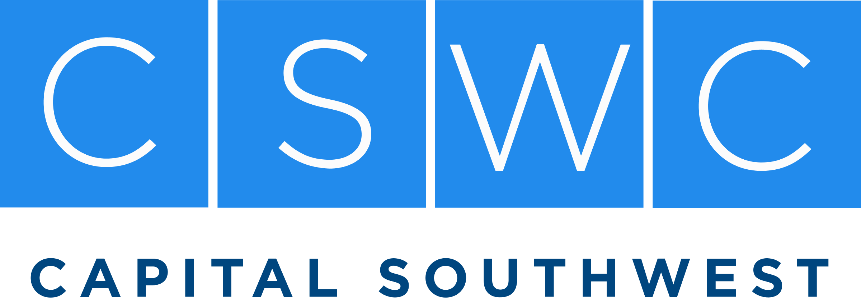 |  |  |  |  |  | 8333 Douglas Avenue, Suite 1100  Dallas, Texas 75225  T 214.238.5700  F 214.238.5701
Dear Fellow Shareholder,
I am reaching out personally because you are one of our larger shareholders, and your investment in Capital Southwest is important to us. This is not a generic shareholder solicitation, but rather a sincere request for your help in approving a proposal that is essential to Capital Southwest's continued success and long-term shareholder value creation.
For our Annual Meeting to be held on September 1st, the proposal before shareholders is to increase Capital Southwest's authorized shares. While that may sound like a technical corporate matter, this issue is far more important and essential to the Company's success moving forward. The proposal is critical to preserving the financial flexibility that has helped drive our growth, support prudent balance sheet management, and create long-term shareholder value.
If it would be helpful, I am happy to speak with you directly to answer any questions and explain why your vote is so important. You can reach me on my cell at 202-997-1797, my direct office line at 214-884-3829, or by email at msarner@capitalsouthwest.com.
Approval does not result in an immediate issuance of shares. Rather, it preserves a tool that has been instrumental to our success over many years and has helped support our growth, maintain balance sheet flexibility, and create long-term shareholder value.
While we have received strong support to date, we remain well short of the votes required for approval. Because Texas law requires approval from holders of at least two-thirds of all outstanding shares, a failure to vote has the same practical effect as a vote against the proposal.
If you have not yet voted, I respectfully ask that you do so today. Your vote is important, and your support will help ensure that Capital Southwest retains the flexibility needed to continue executing the strategy that has served shareholders well over time.
Thank you for your continued support and partnership. Please do not hesitate to contact me directly if I can be helpful.
Sincerely,
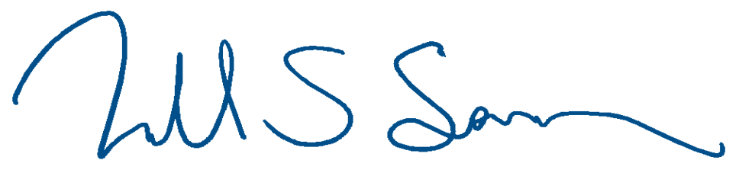



President & Chief Executive Officer
msarner@capitalsouthwest.com
Office 214.884.3829 | Cell 202.997.1797

