UNITED STATES
SECURITIES AND EXCHANGE COMMISSION
WASHINGTON, D.C. 20549

SCHEDULE 14A

Proxy Statement Pursuant to Section 14(a) of the
Securities Exchange Act of 1934 (Amendment No. )
Filed by the Registrant ☒
Filed by a Party other than the Registrant o
Check the appropriate box:
o |  |  |  |  |  | Preliminary Proxy Statement
o |  |  |  |  |  | Confidential, For Use of the Commission Only (as permitted by Rule 14a-6(e)(2))
o |  |  |  |  |  | Definitive Proxy Statement
☒ |  |  |  |  |  | Definitive Additional Materials
o |  |  |  |  |  | Soliciting Material Pursuant to Rule 14a-11(c) or Rule 14a-12
CAPITAL SOUTHWEST CORPORATION
(Name of Registrant as Specified In Its Charter)
(Name of Person(s) Filing Proxy Statement, if Other Than the Registrant)
Payment of Filing Fee (Check the appropriate box):
☒ |  |  |  |  |  | No fee required.
o |  |  |  |  |  | Fee paid previously with preliminary materials.
o |  |  |  |  |  | Fee computed on table in exhibit required by Item 25(b) per Exchange Act Rules 14a-6(i)(1) and 0-11.

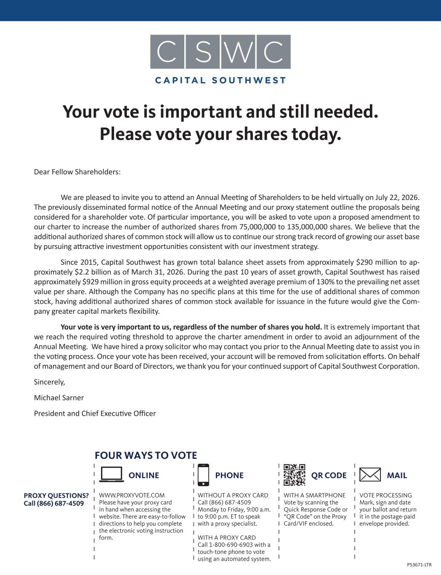
Your vote is important and still needed. Please vote your shares today. P53671-LTR Dear Fellow Shareholders: We are pleased to invite you to attend an Annual Meeting of Shareholders to be held virtually on July 22, 2026. The previously disseminated formal notice of the Annual Meeting and our proxy statement outline the proposals being considered for a shareholder vote. Of particular importance, you will be asked to vote upon a proposed amendment to our charter to increase the number of authorized shares from 75,000,000 to 135,000,000 shares. We believe that the additional authorized shares of common stock will allow us to continue our strong track record of growing our asset base by pursuing attractive investment opportunities consistent with our investment strategy. Since 2015, Capital Southwest has grown total balance sheet assets from approximately $290 million to ap- proximately $2.2 billion as of March 31, 2026. During the past 10 years of asset growth, Capital Southwest has raised approximately $929 million in gross equity proceeds at a weighted average premium of 130% to the prevailing net asset value per share. Although the Company has no specific plans at this time for the use of additional shares of common stock, having additional authorized shares of common stock available for issuance in the future would give the Com- pany greater capital markets flexibility. Your vote is very important to us, regardless of the number of shares you hold. It is extremely important that we reach the required voting threshold to approve the charter amendment in order to avoid an adjournment of the Annual Meeting. We have hired a proxy solicitor who may contact you prior to the Annual Meeting date to assist you in the voting process. Once your vote has been received, your account will be removed from solicitation efforts. On behalf of management and our Board of Directors, we thank you for your continued support of Capital Southwest Corporation. Sincerely, Michael Sarner President and Chief Executive Officer PROXY QUESTIONS? Call (866) 687-4509 WWW.PROXYVOTE.COM Please have your proxy card in hand when accessing the website. There are easy-to-follow directions to help you complete the electronic voting instruction form. ONLINE VOTE PROCESSING Mark, sign and date your ballot and return it in the postage-paid envelope provided. MAIL FOUR WAYS TO VOTE PHONE WITHOUT A PROXY CARD Call (866) 687-4509 Monday to Friday, 9:00 a.m. to 9:00 p.m. ET to speak with a proxy specialist. WITH A PROXY CARD Call 1-800-690-6903 with a touch-tone phone to vote using an automated system. WITH A SMARTPHONE Vote by scanning the Quick Response Code or “QR Code” on the Proxy Card/VIF enclosed. QR CODE

