UNITED STATES
SECURITIES AND EXCHANGE COMMISSION
WASHINGTON, D.C. 20549

SCHEDULE 14A

Proxy Statement Pursuant to Section 14(a) of the
Securities Exchange Act of 1934 (Amendment No. )
Filed by the Registrant ☒
Filed by a Party other than the Registrant o
Check the appropriate box:
o |  |  |  |  |  | Preliminary Proxy Statement
o |  |  |  |  |  | Confidential, For Use of the Commission Only (as permitted by Rule 14a-6(e)(2))
o |  |  |  |  |  | Definitive Proxy Statement
☒ |  |  |  |  |  | Definitive Additional Materials
o |  |  |  |  |  | Soliciting Material Pursuant to Rule 14a-11(c) or Rule 14a-12
CAPITAL SOUTHWEST CORPORATION
(Name of Registrant as Specified In Its Charter)
(Name of Person(s) Filing Proxy Statement, if Other Than the Registrant)
Payment of Filing Fee (Check the appropriate box):
☒ |  |  |  |  |  | No fee required.
o |  |  |  |  |  | Fee paid previously with preliminary materials.
o |  |  |  |  |  | Fee computed on table in exhibit required by Item 25(b) per Exchange Act Rules 14a-6(i)(1) and 0-11.

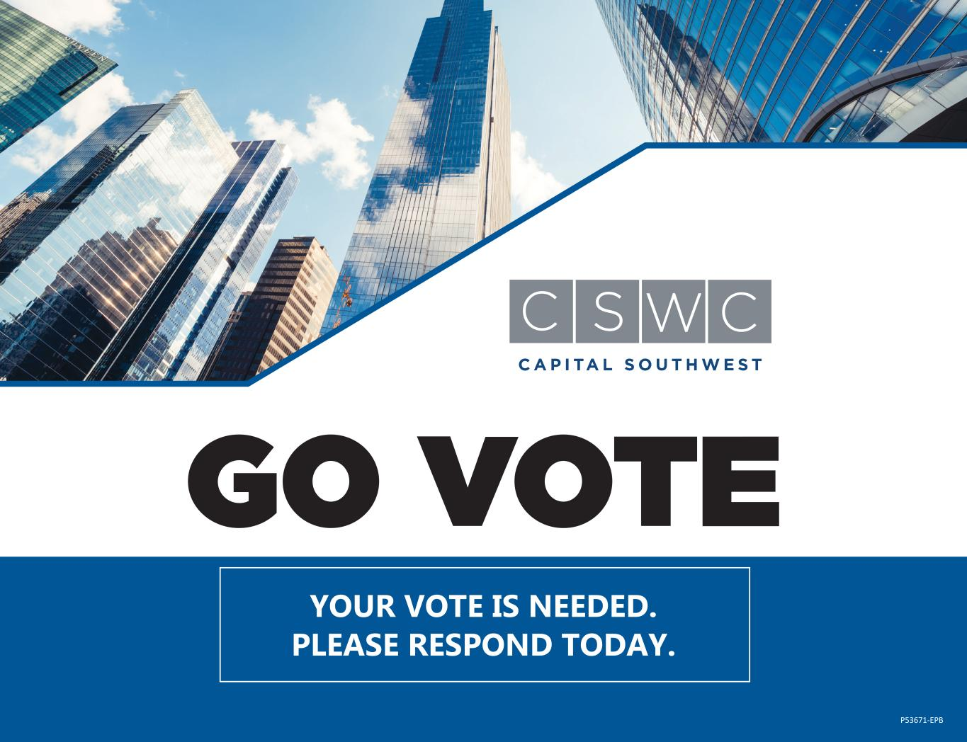
YOUR VOTE IS NEEDED. PLEASE RESPOND TODAY. P53671-EPB

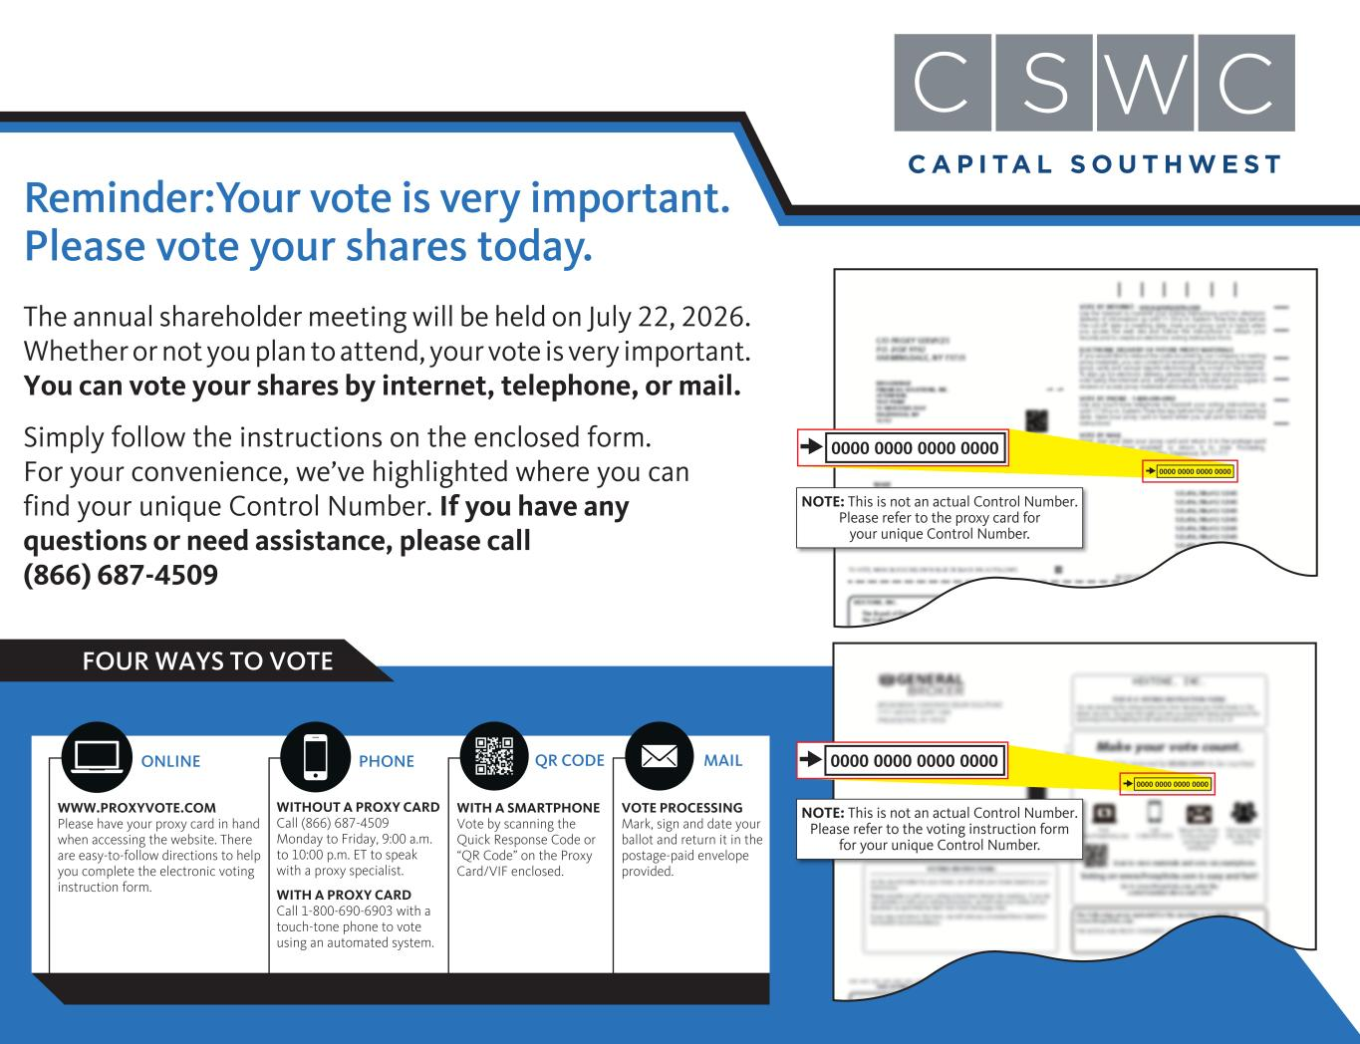
Reminder:Your vote is very important. Please vote your shares today. The annual shareholder meeting will be held on July 22, 2026. Whether or not you plan to attend, your vote is very important. You can vote your shares by internet, telephone, or mail. Simply follow the instructions on the enclosed form. For your convenience, we’ve highlighted where you can find your unique Control Number. If you have any questions or need assistance, please call (866) 687-4509 FOUR WAYS TO VOTE 0000 0000 0000 0000 0000 0000 0000 0000 0000 0000 0000 0000 0000 0000 0000 0000 NOTE: This is not an actual Control Number. Please refer to the voting instruction form for your unique Control Number. NOTE: This is not an actual Control Number. Please refer to the proxy card for your unique Control Number. WWW.PROXYVOTE.COM Please have your proxy card in hand when accessing the website. There are easy-to-follow directions to help you complete the electronic voting instruction form. VOTE PROCESSING Mark, sign and date your ballot and return it in the postage-paid envelope provided. WITH A SMARTPHONE Vote by scanning the Quick Response Code or “QR Code” on the Proxy Card/VIF enclosed. PHONE MAILQR CODEONLINE WITHOUT A PROXY CARD Call (866) 687-4509 Monday to Friday, 9:00 a.m. to 10:00 p.m. ET to speak with a proxy specialist. WITH A PROXY CARD Call 1-800-690-6903 with a touch-tone phone to vote using an automated system.

